David Pierce – Career Planning Document

**Explore the Landscape**

In my career to-date, I have frequently been tasked with taking large sets of data, and packaging it into digestible format for audiences. I think I have a knack for this—understanding what is relevant to clients, and choosing the best way to visualize a given trend.

The results of this survey make sense to me, I present about 50 times per year to audiences ranging from 5-400 people. Earlier in my career, I often included visuals that were overly complex, with too many moving parts. Over time, I’ve found ways to simplify what I’m presenting but ultimately make the message more readable and powerful. Central to that is finding better ways to visualize data, and make the processes I use to create visualizations repeatable (and user-friendly, so others on my team could use them as well). Improving my visualization and data wrangling/manipulation skills has been central to this improvement. Adding python skills to the mix should only help me take this to the next level.

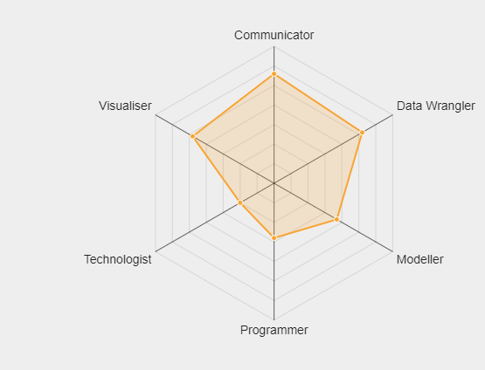

**Survey the Job Market**

Currently, my goal is to continue at my current company, but move into a position where I am more uniformly focused on data analytics/visualization/product design. This process is well underway, and I’m fortunate to have the backing of my superiors.

**Find Your People**

<https://www.meetup.com/Data-Wranglers-DC/>

<https://www.meetup.com/Power-BI-DC/>

<https://www.meetup.com/Data-Visualization-DC/>

<https://www.meetup.com/Geospatial-Big-Data-Analytics-DC/>

**Write your own story**

1. Describe your ideal job in one or two paragraphs as though you're talking with an industry professional. They're familiar with the business and with the culture, they know the jargon and the buzzwords. Focus on the skills, tools, and / or industry you hope to deeply specialize in.
   1. My ideal job involves working with large sets of data, and using various skills to manipulate, analyze, and visualize this data. I’ve had substantial experience finding novel applications for large data sets, ultimately creating new frameworks for how my teams at work have visualized and presented data to clients. More recently, I’ve used these skills to come up with new ways to visualize data in our actual product. In my ideal job, I have similar opportunities to work with large sets of data, creating novel and powerful ways to visualize and analyze data.
   2. Fluency with SQL, python, powerBI, ARCGIS (or other GIS software), and excel will be central to this job
2. Describe your ideal job in one or two paragraphs as though you're talking with a non-technical family member or friend. Avoid jargon and keep things simple while remaining specific. If you went deep in your specialization above, emphasize here the breadth of skills and work.
   1. My ideal job involves taking large, raw sets of data and transforming that into highly powerful, highly readable content. This might involve taking a hundred million rows of data—let’s say apartment rent data for the entire united states—and transforming that into powerful analyses at a regional, subregional, and property level.
3. Synthesize the two exercises above into a short aspirational "professional summary" that might be appropriate on your LinkedIn profile, resume, or portfolio in the future.
   1. My strength as a data science lies my ability to take a large set of raw data, and understand how this data can be manipulated to create the most powerful and relevant analysis or visualization. My career up to this point has involved creating numerous frameworks for how my team visualizes and communicates various metrics across the world of commercial real estate data. These frameworks are designed to be highly automated, repeatable, digestible, and user-friendly (if it’s a ‘tool’ created to be used by my broader team). I hope to carry these skills into my future data science endeavors, and believe my substantial library of work in this field to-date will speak for my potential value on a team.